If we just used this : wb = openpyxl.load_workbook('Trappes.xlsx', data_only=True)

While writing the file we get:

UserWarning: Data Validation extension is not supported and will be removed

Better use this:

First open excel file . Click on Fischier

And unlock data protection by ‘Oter la protection’ 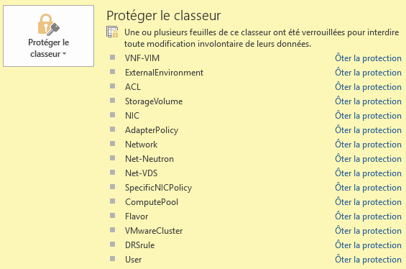

And in code use : wb = openpyxl.load_workbook('test.xlsx', data_only = 'True')

Don’t use above method:

If we use :

wb = openpyxl.load_workbook('test3.xlsx', data_only = 'True')

‘data only’ will remove all formulas from the excel and we will lose multiple features of original file.

Use below method:

Copy original file ‘NFVsocle-LP97004-v1.10-Expression de Besoins NFV POP5 Trappes.xlsx’ to test3.xlsx

In python use:

wb = openpyxl.load_workbook('test3.xlsx')

And Click on for the Sheet you are going to modify ‘Oter la protection’ , this will prevent below error:

UserWarning: Data Validation extension is not supported and will be removed.

If only one data store of type 'datastore-fcoe' is exist , then keep on 1st line .

Steps to Add new VNF:

Get latest file in C:\Users\u157740\Desktop\django\EB_socle

Copy the file and name it as test3.xlsx

Open file test3.xlsx and remove ‘oter la protection’ from all sheets

Create the file ‘update_date.xlsx’ with new vnf info

Open Visual studio and in terminal go to path C:\Users\u157740\Desktop\django\EB_socle

Activate environment to run the python program with command: .\env_EB\Scripts\activate

Create copy of auto_exp.py with updated file names (test3.xlsx and update_date.xlsx)

Launch the script to do the changes

(env_EB) PS C:\Users\u157740\Desktop\django\EB_socle> python .\auto_exp.py